MOR8 – Kontent Setup

- Purpose and Scope

The purpose of this procedure is to set out the exact process for setting up new products on Kontent, which is part of the Mortgage Launch Full Process (MOR1).This process is fully owned by the Product Development Admin team.

System Access Required: Product Dev Shared Folder, Kontent

Time Allowance: 15 Minutes per product

- Version Control

No. | Date | Comments
1 | 21.05.2021 | Version 1
2 | 12.06.2023 | Version 2 – New Kontent system updated
3 | 23/02/2024 | Replaced instances of “Kontent” with “Kontent”  Added details of Intermediaries website products

3. Process
3.1. Understanding
Kontent is the tool we use to create our product pages on the Newcastle Building Society website so that direct and intermediary customers are able to see the full range of available products. Not all of our product launches will require this step; it will mainly be Acquisition Residential products. Creating and maintaining the product

3.2. Process – Kontent Setup
Log into Kontent via this link Kontent. You will require access to Kontent which is provided by Digital Marketing before you are able to access the system. They will provide you both the username and password to access the system.

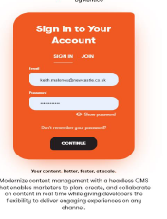

You will also need to set up Kontent within your Microsoft Authenticator App so that you can get a passcode each time you sign on. When you access KONTENT you will see the screen below:
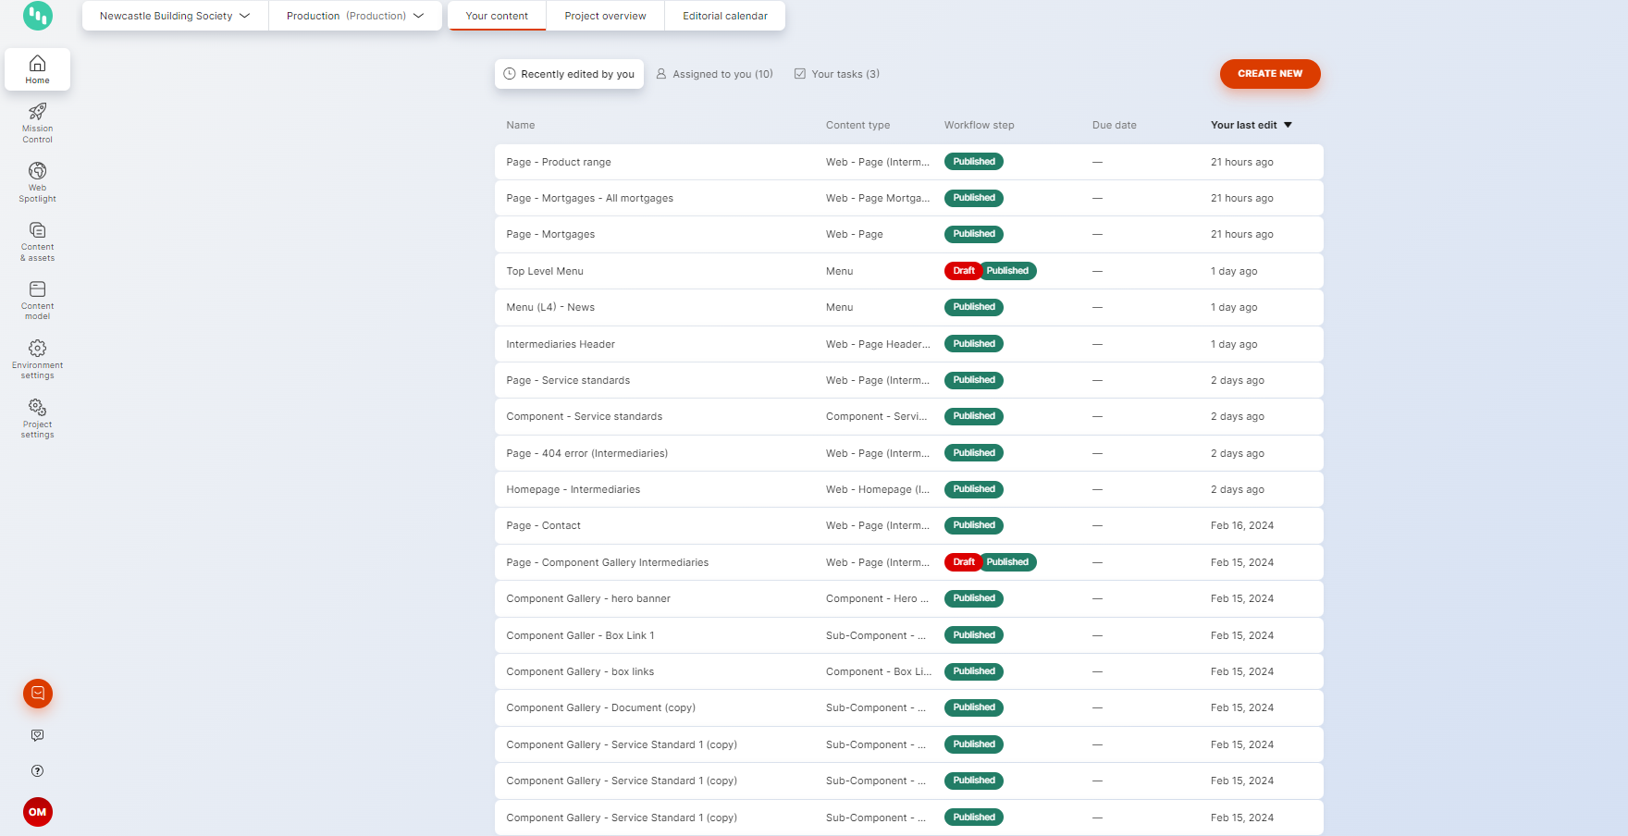
To set up a new Mortgage product you must create both a ‘Product’ page and the ‘Page’ that the product information will sit on. When setting up a new product, it is useful to have an equivalent current live product open as there is generic information to be included in sections of the webpage.

3.3. Process – ‘Product’ page setup
To set up a ‘Product’ page go to ‘Content & Assets’ and select ‘Create New’.
NOTE: this should be completed for all direct and intermediary products.
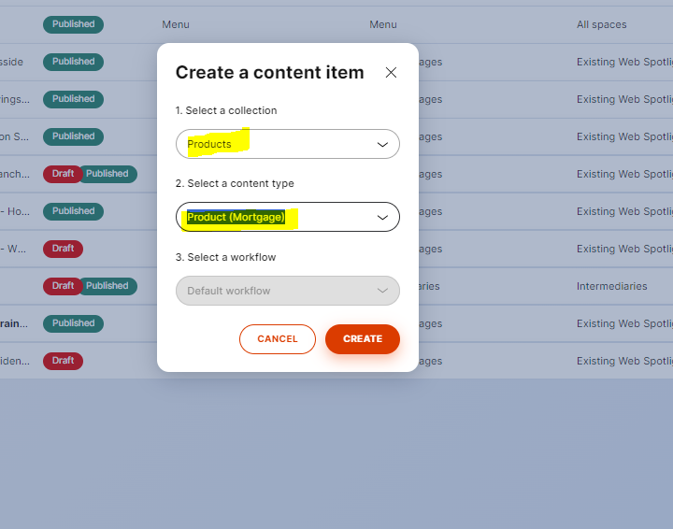
In ‘Select a collection’ choose ‘Products’ and ‘content type’ is ‘Product (Mortgage)’. When you click ‘create’ a new blank page will appear.

Content item name:
Name the Mortgage Product content item using the following format:
Product – Mortgage – [product code] – [product name]
For example: Product - Mortgage - EFFX945 - 2 Year Fixed Rate Mortgage
If the product type is non-standard LTV (ie Large Loan, Interest Only etc.) this information should be included in the format of the name.
For example: Product - Mortgage - EFFX945 - 2 Year Fixed Rate Mortgage – Large Loan
This should reflect the product code (from eMAP) followed by the term and type of product (ie. EFII001 – Two Year Fixed Rate Mortgage – Repayment Only)

Product Detail:
The product detail tab covers the specific product criteria to be included. This information is mostly available from the Product Launch Briefing Document, with the only exceptions being the ‘APRC’ and ‘Illustration’ which are taken from the relevant APR calculation for the product you are setting up. An example product is shown below to cover which information should be included within this tab:

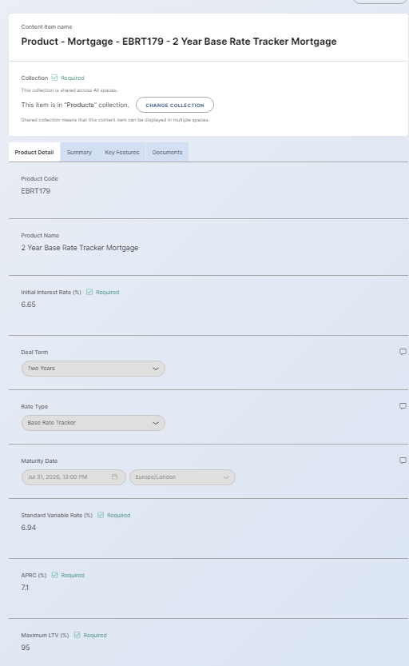
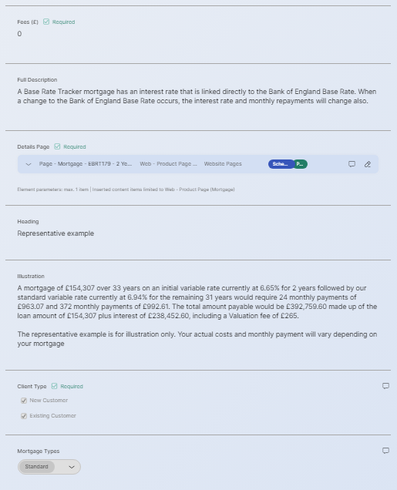
Note: Since the last version of this guide Product Code, Client Type and Mortgage Types have been added to this list. They power the mortgage listing page filters and should be completed for every product.
The ‘Details Page’ section is where we link the product content to the product page in which it will sit. How to set this up is covered later in this process document.

Summary:
The Summary tab covers further product detail to be included. Some of this is standard, such as the ‘Daily Interest Calculation’ and ‘Minimum Term’ whilst other information is specific to the product you are setting up:

Key Features:
The Key Features tab is standard information depending on the product being set up (i.e. 2 / 5 year fixed, discounted variable products all have their own content (You can take this from an existing page for the product type you are setting up). An example of a 2 year fixed product is below:
Document:
The Documents tab is automatically populated with the relevant ‘summary of fees’ and ‘General T&Cs’. If these are missing you should raise this with Digital Marketing.
3.4. Process – ‘Page’ setup
NOTE – there is a process change from the previous version of the guide. These steps from here should be followed closely.
To set up a ‘Product’ page go to ‘Content & Assets’ and select ‘Create New’.
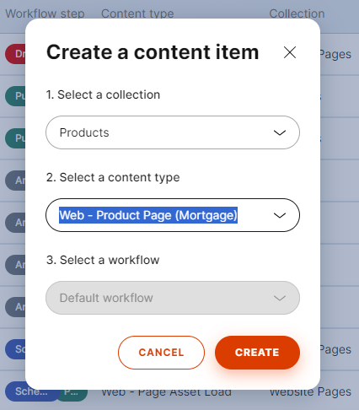
The page will appear as per the above. The content item name follows the same formats when you set up the product, however you just replace ‘Product’ with ‘Page’:
Page - Mortgage – EFII742 - 2 Year Fixed Rate Mortgage
The title follows the same formatas when you set up the product:
2 Year Fixed Rate Mortgage
The URL will automatically populate when you add in the title, however you then need to add in the product code so that it differentiates from other products:
efii742-2-year-fixed-rate-mortgage
Adding the Product to the Page
The page will include the optionto add the relevant product and will look like the below:
Click ‘Add Existing Items’ and search for the product (use the product code) that you are adding to the page. N.B -You will need to de-select the following:
When you find the ‘Product’ that you created earlier, tick the box next to it and then click ‘Add’. The ‘Product’ will then appear on the ‘Page’ section as per the below:
Click the ‘Edit’ pencil button (highlighted above) and this will take you to the ‘Product’ where you can add the ‘Page’ in the ‘Product Detail’ tab in the same way that you added the ‘Product’ to the ‘Page’:
Once the 2 have been linked to each other the product willneed to be checked by a colleague. Once it has been checked the product can be published. This can be done by either publishing immediately (if the productshould go live straight away) or you can schedule publish. At the top of the
page there will be an option to publish.

This will bring up the screen below where you select either ‘publish now’or ‘schedule publish’. Once you have selected the option you want (and input the date and time for ‘schedule publish’ you will be given the option to also publish the product information at the same time. you should select the tick box to do this so that all the product information publishes at the same time:
If you don’t publish the page and the product at the same time there will be an error online and the product will not display correctly. Once the box is ticked, click on ‘Publish item with selected item’.

3.5 – Adding mortgages to the relevant website
Note: Each website will only pick up mortgages that are in its “tree” (web spotlight). If you create a mortgage and do not add it to the “tree” (web spotlight) of the website you want to display it on it won’t show.
You therefore need to add all of the Web – Product Page (Mortgage) to the intermediaries website and only the direct only Web – Product Page (Mortgage) to Newcastle.
3.5.1 – Adding mortgages to Newcastle.co.uk
Navigate to “Web Spotlight” and ensure you are in “Existing Web Spotlight”
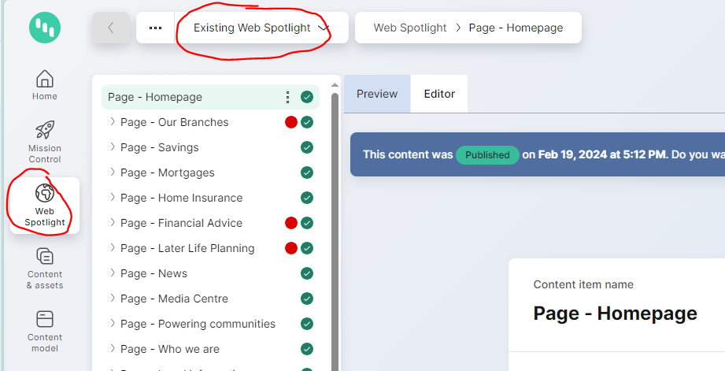
Navigate to ‘All Mortgages’ section (Page – Mortgages – All Mortgages) click the 3 dots next to the name and select ‘Create a new version’ of the ‘All Mortgages’ page. This will put this page into draft and allow you to add a new mortgage product to the ‘All Mortgages’ page (note if it’s already in draft you can skip that step):
Navigate to the “subpages” section and click “add existing items”
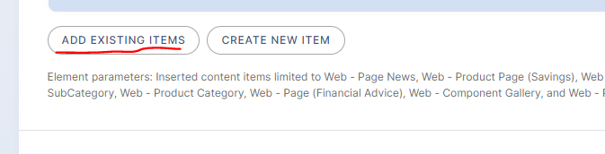
For ease clear all filters and just select “Web – Product Page (Mortgage) to show all mortgages
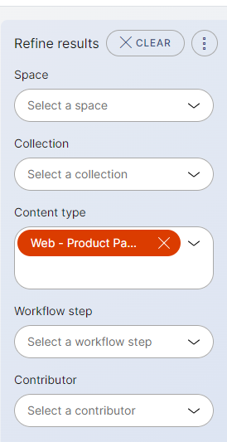
Check the mortgages that are relevant to NBS and click “add”.
Back on all mortgages page you can delete any archived mortgages.
The final part of the process you need to complete is to publish the ‘All Mortgages’ section (Page – Mortgages – All Mortgages). If you don’t do this the product will not show correctly on the website, potentially causing issues for customers.
3.5.2 – Adding mortgages to newcastleforitnermediaries.co.uk
Navigate to “Web Spotlight” and ensure you are in “Intermediaries”
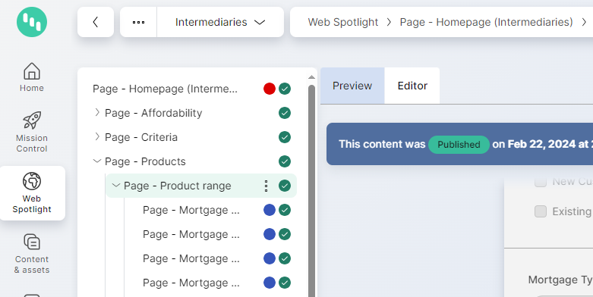

Navigate to ‘Product Range’ section (Page – Product Range) click the 3 dots next to the name and select ‘Create a new version’ of the ‘All Mortgages’ page. This will put this page into draft and allow you to add a new mortgage product to the ‘Product Range’ page (note if it’s already in draft you can skip that step):
Navigate to the “subpages” section and click “add existing items”
For ease clear all filters and just select “Web – Product Page (Mortgage) to show all mortgages.
Check the mortgages that are relevant to Intermediaries and click “add”.
Back on the ‘product range’ page you can delete any archived mortgages.
The final part of the process you need to complete is to publish the ‘Product Range’ section (Page – Product range. If you don’t do this the product will not show correctly on the website, potentially causing issues for brokers.

